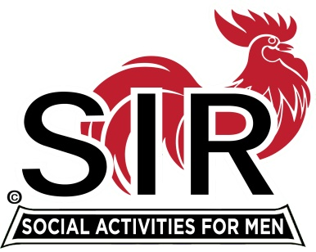
Certificate of Membership

Be it known to all those present that

Tony DeGrassi

Has Been Duly Accepted as a Member of
Sons In Retirement

Las Trampas Branch No. 116

Dated this 21st Day of October, 2019

Attest: Sam Beret Jerry Hicks

Sam Beret, Member Relations Jerry Hicks, Big Sir

